|  |
| --- |
| *Ahsanullah University of Science & Technology*logo.jpgDepartment of Computer Science & Engineering |
| Shop Management System |
| CSE 3104 ( DBMS SESSIONAL) |
|  |
|  |
|  |

|  |  |
| --- | --- |
| Submitted By: | |
| Mohimenul Islam Rajib | 16.01.04.096 |
| Abir Hossain Xian | 16.01.04.100 |
|  |  |
|  |  |

|  |
| --- |
|  |

INTRODUCTION

Shop Management System is a common service for Shop owners and customers.

Two parties can use this application to trade. Shop owners can add their product which is visible by the customer and can be ordered by this app.

MOTIVATION

We are moving forward to the future so why e should waste out valuable time and energy to buy goods/products physically when we can use this kind of software to order our goods.  
  
PLATFORMS  
  
PC and any platform that runs java application  
  
FEATURES:

* Admin can add new store
* Admin can add new products
* Admin can increase and decrease product quantity available to each shop
* Customer can register to this software
* Customer have to login through this application to use this software
* Customer can choose his/her product and make a order
* Admin can view all orders and give update to shop owners/workers for delivery

ENTITY RELATIONSHIP DIAGRAM

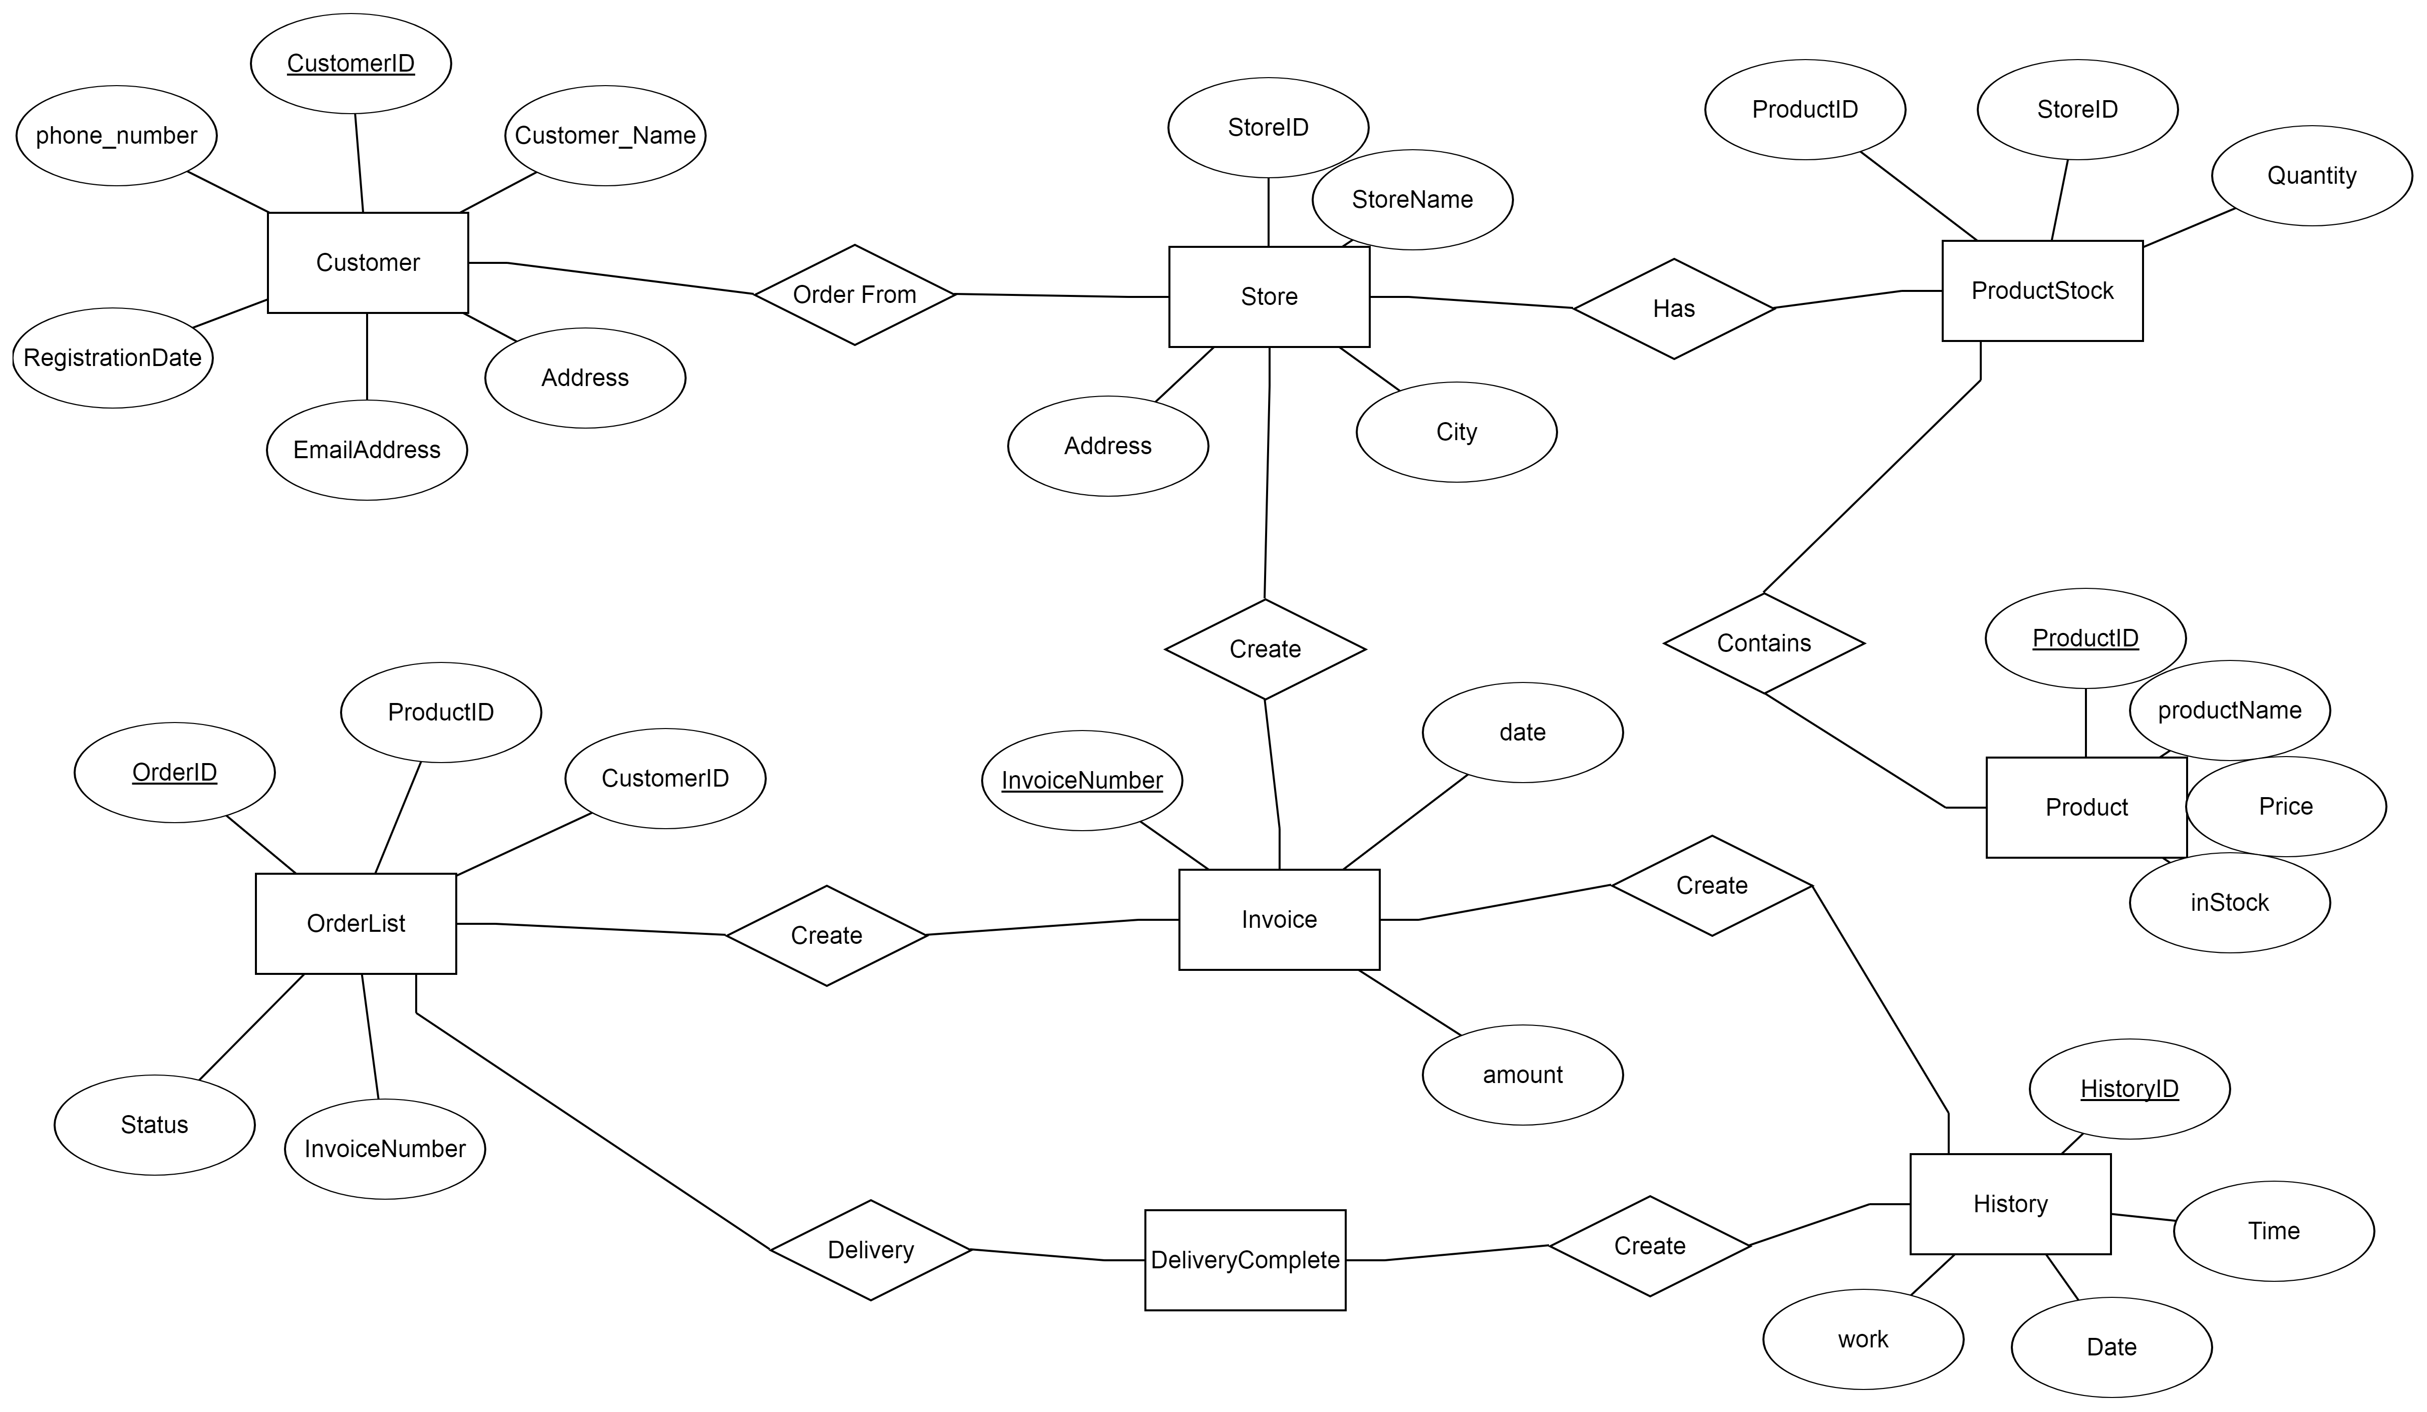

**DESIGN AND TECHNICAL RESOURCE**:  
  
Netbeans IDE, Java Swing, Microsoft SQL Server Management Studio **REUSEBILITY**This software can be reusable for certain situation.  
  
WORK FLOW

For customer work flow is to register/login to exiting account then order products from the list.

For Admin is to login and then can manage store and products also can see all the orders from the customer.

ADVANTAGE:

* Simple log in and registration system for customer/gamer.
* User-friendly interface for gamers and admins.
* Easily updatable database.
* Simple querying feature to retrieve data from database.
* Important statistics of the store made available to admin.

LIMITATIONS :

FUTURE SCOPE:  
  
This software can be upgraded to an bigger e-comers Software in the future.  
  
  
Conclusion  
  
In conclusion this is a good software for any kind of customer and shoppers who is ready for be the part of the future.